202: Principles of electrical science  
**Sample questions version A**

**There are 40 multiple choice questions. Answer them all, selecting the correct answer out of the four provided.**

1. Which is the correct formula to find I from the formula P =I2R? (L 1.1)
2. Calculate the cosine of the following angle (a) in the figure below. (L 1.1)

5

a

4

* 1. 37.5

6.4

* 1. 0.78
  2. 0.63
  3. 0.8

1. The SI unit for Impedance is? (L2.2)
   1. Watts
   2. Henrys
   3. Hertz
   4. Ohm’s
2. The electrical quantities symbol for Inductive Reactance is? (L2.2)
   1. W
   2. XL
   3. Y
   4. Z
3. Kelvin is the measurement of? (L2.1)
   1. Length
   2. Area
   3. Mass
   4. Temperature

1. Which instrument would be used to measure Power? (L2.3)
   1. Ohm meter
   2. Volt meter
   3. Watt meter
   4. Amp meter
2. The SI unit for Energy is the? (L2.2)
   1. Watts
   2. Joule
   3. Ohm
   4. Farad
3. A 25 kilogram bag of cement falls to the ground from a height of 5 meters. (L3.4)  
   How much force will the bag hit the ground with?
   1. 245.25N
   2. 5J
   3. 125N
   4. 196.2J
4. A wheel barrow is an example of a: (L3.2)
   1. Class 1 lever
   2. Class 2 lever
   3. Class 3 lever
   4. Class 4 lever
5. Calculate the effort required to lift a 10 Newton load with (L3.4)  
    a crowbar in the figure below.  
   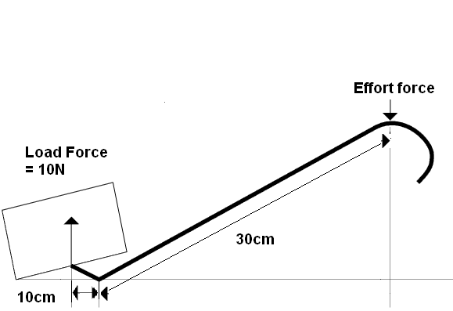  
   1. 33 Newton’s
   2. 0.3 Newton’s
   3. 3.3 Newton’s
   4. 6 Newton’s
6. One set of gears are connected together. The smaller cog has 12 teeth (L3.4)   
   and the larger cog has 20 teeth. The smaller cog rotates 40 times  
   per second. How many times per second will the larger cog rotate?
   1. 24 times per second
   2. 67 times per second
   3. 58 times per second
   4. 87 times per second
7. Two pulleys are used to lift a load of 19000 Newton’s, 4 metres (L3.4)  
   above a surface. How much effort would be required to lift the load?

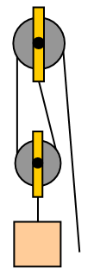

* 1. 4750 Newton’s
  2. 9500 Newton’s
  3. 76000 Newton’s
  4. 38000 Newton’s

1. An electric motor has an input of 4kW and an output of 3.3KW. (L3.4)   
   The efficiency of the motor is?
   1. 90%
   2. 100%
   3. 82.5%
   4. 121%
2. What is the correct formula for calculating work done? (L3.3)
 $Work done = \frac{force }{distance}$

  1. Work done = mass x acceleration x time taken
 $Work done = \frac{distance }{force}$

  2. Work done = force x distance
3. Which of the following statements is true? (L4.1)
   1. Electrons are positively charged and Protons are negatively charged.
   2. Electrons are negatively charged and Protons are positively charged.
   3. Neutrons are negatively charged and Protons are positively charged.
   4. Electrons are negatively charged and Neutrons are positively charged.
4. Identify the material which could act as an insulator. (L4.2)
   1. Gold
   2. Tungsten
   3. Glass
   4. Aluminium
5. A 6mm2 cooper conductor has a resistivity of 1.78x10-8 and is (L4.3)  
   87 meters long. What is the resistance of the conductor?
   1. 0.26 Ohms
   2. 2.6 Ohms
   3. 26µ Ohms
   4. 26m Ohms
6. Which of the following materials would have the lowest resistivity? (L4.3)
   1. Air
   2. Aluminium
   3. Iron
   4. Copper
7. Which of the following statements is correct? (L4.4)
   1. As the voltage and the current increases, the resistance will decrease.
   2. As voltage increases, the current will also increase if the resistance stays the same.
   3. Current will decrease if resistance decreases and voltage stays the same.
   4. Voltage will increase if resistance increases and the current increases.
8. Which formula predicts the effect of Voltage, Current and Resistance? (L4.4)
$V=IR$

$V=\frac{I}{R}$

$V=\frac{R}{I}$

$V=I^{2}R$

9. As current flows in a series circuit, the current will: (L4.4)
   1. increase as it returns to the supply.
   2. decrease as it flows through each resistor of the circuit.
   3. stay the same throughout the circuit.
   4. not flow as the circuit is not connected in parallel.
10. Three resistors of equal value are placed in series and are connected (L4.5)  
    to a 12 Volt supply, 1.3 Amps flows through the resistors. What are   
    the values of each of the resistors?
    1. 2.3 Ohms
    2. 3 Ohms
    3. 2 Ohms
    4. 3.2 Ohms
11. Four resistors with values of 12 Ohms, 7.5 Ohms, 9 Ohms and 4.8 Ohms (L4.5)  
    are wired in parallel and connected to a 110 Volt supply. How much   
    current will flow through the 7.5 Ohm resistor?
    1. 14.7 Amps
    2. 9.2 Amps
    3. 12.2 Amps
    4. 23 Amps
12. What is the total resistance of the following resistors when wired in parallel: (L4.5)  
    13 Ohms, 25 Ohms, 6 Ohms, 18 Ohms and 9 Ohms?

9Ω

18Ω

6Ω

25Ω

13 Ω

* 1. 71 Ohms
  2. 7.1 Ohms
  3. 2.2 Ohms
  4. 22 Ohms

1. A circuit has a total resistance of 12 Ohms and 6.44 Amps flows through it. (L4.6)  
   How much power will the circuit dissipate?
   1. 77 Watts
   2. 1.86 Watts
   3. 927 Watts
   4. 498 Watts
2. An electric heater with a resistance of 16 Ohms is connected to a (L4.6)  
   220 Volt d.c. supply. What is the power dissipated by the heater?
   1. 13.8 Watts
   2. 0.073 Watts
   3. 3 kilowatts
   4. 3520 Watts
3. Calculate the volt drop of a circuit with a resistance of 1.2 Ohms with a (L4.7)  
   current flow of 15 Amps.
   1. 18 Volts
   2. 12.5 Volt
   3. 0.08 Volts
   4. 6 Volts
4. Which of the following effect would happen to a circuit if the current flow (L4.8)  
    in the circuit was to increase?
   1. The voltage of the circuit would increase
   2. The resistance of the circuit would increase
   3. The magnetic field would decrease
   4. The power in the circuit would collapse
5. The effect that allows us to perform electroplating is: (L4.8)
   1. Magnetic
   2. Thermal
   3. Chemical
   4. Solar
6. The Tesla is the measurement for: (L5.2)
   1. Magnetic flux density
   2. Magnetic flux
   3. Induction
   4. Frequency
7. The correct formula to calculate Magnetic flux density is: (L5.2)
$β=\frac{φ}{A}$

$β=\frac{A}{φ}$

$β=φ^{2}A$

$φ=\frac{β}{A}$

8. Two current carry conductors are placed side by side (see fig below). (L5.3)  
   What will happen to the conductors?  
     
     
     
     
   1. They will rotate clockwise around each other
   2. The magnetic field of each conductor will cancel each other out
   3. They will repulse away from each other
   4. They will attract towards each other
9. Identify where the South Pole would be on this solenoid (see fig below). (L5.3)

D

C

B

A

* 1. A
  2. B
  3. C
  4. D

1. A current carrying conductor is placed within a magnetic field. Which (L5.3)  
    direction will the conductor (in the fig below) move?

N

S

* 1. Left
  2. Right
  3. Down
  4. Up

1. An alternator has a frequency of 60Hz. How long does it take to perform (L5.4)  
   two full revolutions?
   1. 330 milliseconds
   2. 17 milliseconds
   3. 60 milliseconds
   4. 33 milliseconds
2. What is the generated emf when a 5000mm long conductor cuts a (L5.4)  
   magnetic field of 0.5 Teslas at a velocity of 0.42 m/s?
   1. 1 V
   2. 1050 V
   3. 105 V
   4. 15 V
3. Which electronic device is designed to store an electrical charge? (L6.2)
   1. Resistor
   2. Diode
   3. Capacitor
   4. Diac
4. 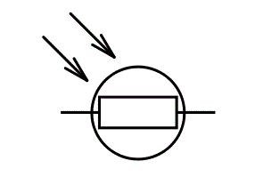Which electronic device has the symbol (in the fig below)? (L6.2)  
     
      
   1. A thermistor
   2. A Light admitting diode
   3. A Thyristor
   4. A light dependant resistor
5. What names are given to the two connections of a diode? (L6.2)
   1. Anode and electrode
   2. Cathode and electrode
   3. Triac and Diac
   4. Anode and Cathode
6. Which of the following electronic devices are suitable for detecting (L6.1)  
   temperature change?
   1. Variable resistor
   2. Thermistors
   3. Zener Diode
   4. Triac